**University of Petroleum and Energy Studies**

School of Computer Science

Department of Cybernetics



**Graphics & Animation Tools**

**LAB FILE**

**(Session: 2020-2021)**

Course: B. Tech with Specialization in Open Source and Open Standards

Batch: 2017-2021

Semester: VIIth

**Submitted By: -**

Divyanshu Gupta

Roll No: R100217023

SAP ID: 500062758

**Submitted To: -**

Dr. Durgansh Sharma Assistant Professor

Department of Cybernetics

Task 1- Create any Mountain Range with Snowfall over it using GIMP

1. Open GIMP, create a new layer with white background.

2. Open an image of the mountain as layers in GIMP and create a new transparent layer to draw boundaries.

3. Use the ‘Paths tool’ over the image and start selecting boundaries and layout of the image.

4. After selection of layout/ boundaries, go to ‘Select’, choose the ‘From Path’ option and your path will be selected.

5. After the path is selected click on ‘bucket fill tool’ from the toolbar and colour the mountain with your desired colour.

6. Repeat step 3,4,5 for creating the grass and sky of the scene.

7. Structure of the mountain scene is complete.

8. Use your creativity to style the snow cap and when you feel it’s good, then place it at the top of the mountain range.

9. For adding snowfall effect, add a new layer of black colour over all the layers and set the photo effect from normal to screen.

10. Go to Filters -> Noise -> RGB Noise and then press ‘OK’, this will add some noise to the image and make it translucent.

11.Again, Go to Filters -> Blur -> Pixelated and then press ‘OK’, this will make the noise effect pixelated. 12.Then, Go to Filters -> Blur -> Motion Blur and then press ‘OK’.

13.After completing the above steps, Go to Colors -> Levels and adjust the white and black input levels till you find a pixelated snow effect over your image.

14.Remove the extra layers.

**Output**

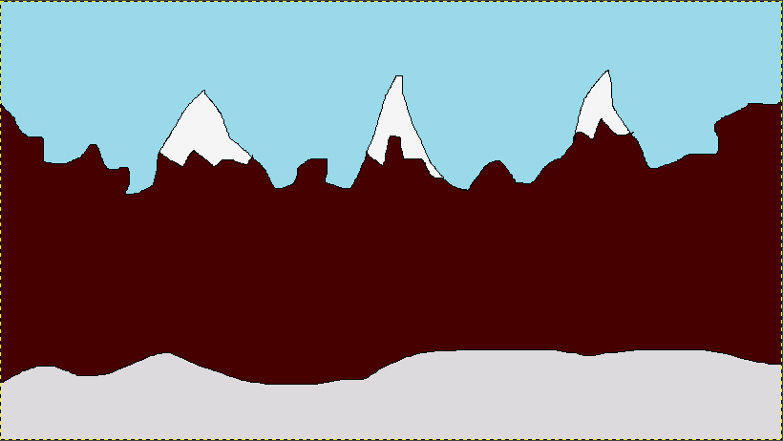

**Task 2- Create any City or Skyscraper using Blender**

* **Added a plane and added road texture to it.**
* **Then transformed the plane according to my need.**
* **Created two car and added texture to both the car.**
* **And then aligned them according to the plane (road)**
* **Created building.**
* **Then added colours to the building.**
* **Then I adjusted the lights accordingly.** 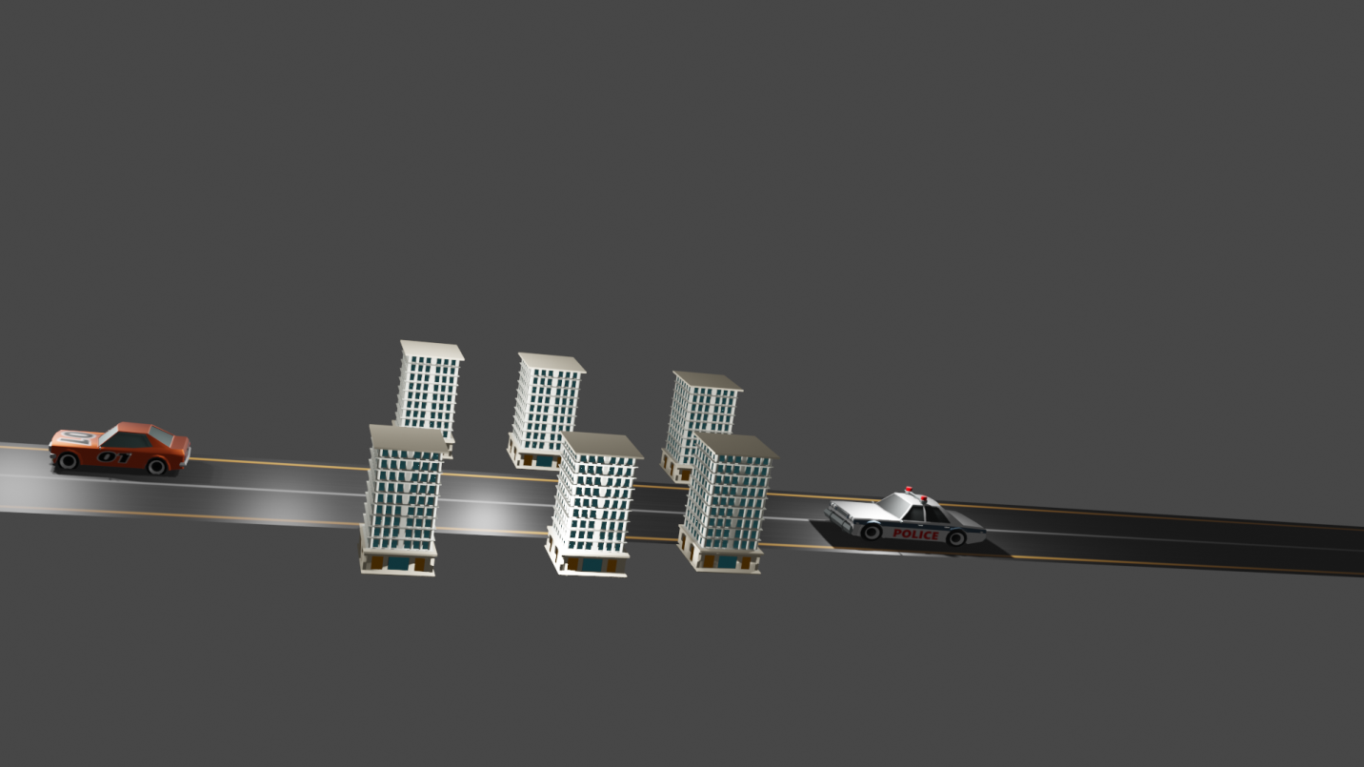
* **Then adjusted the camera view for the city.**